Invitation
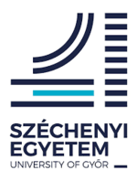
Within the framework of Interreg V-A Slovakia-Hungary Cooperation Programme, we cordially invite you to the lecture series of trainings organized on November 10, 2020 at the Széchenyi István University, Faculty of Agricultural and Food Sciences, Mosonmagyaróvár.

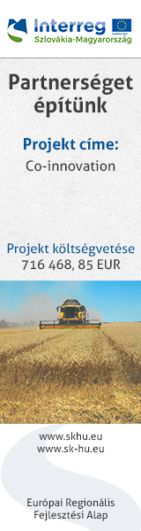
The topics of presentations are: Natural and artificial clay minerals (zeolites), and their structures. Ion exchange on zeolites, the possibilities of using zeolites.

Conference venue:
Széchenyi István University
Faculty of Agriculture and Food Science
Biotechnology Training and Demonstration Center
9200 Mosonmagyaróvár, Lucsony utca 2.

Date: 10/11/2020, 10⁰⁰ hour
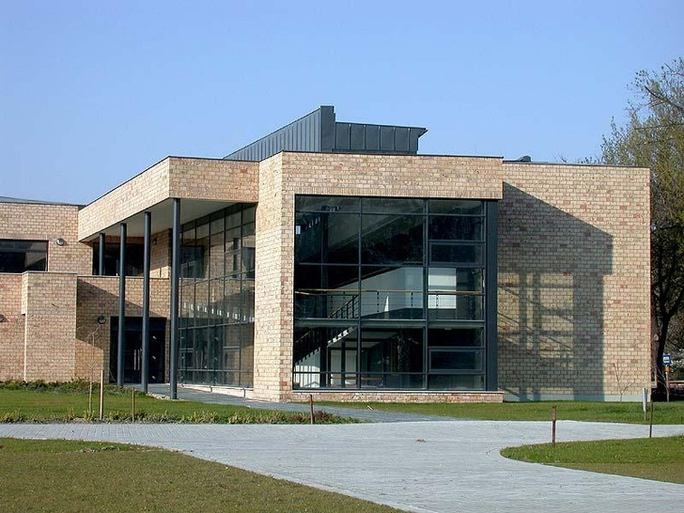
Programme

10⁰⁰ – 10²⁵ Natural and artificial clay minerals (zeolites), and their structure
Lecturer: Dr. Tamas Szakál

10²⁵ - 10⁵⁰ Ion exchange on zeolites, the possibilities of using zeolites
Lecturer: Prof. Dr. Pál Szakál project manager

10⁵⁰ - Professional discussions, debate

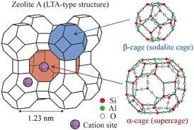

Online connection at the link below:

Meeting ID:
meet.google.com/obr-pcce-ffk

Attendance sheet for online participants:
Ide kattintva elérhető / Dostupné kliknutím sem / Available by clicking here

