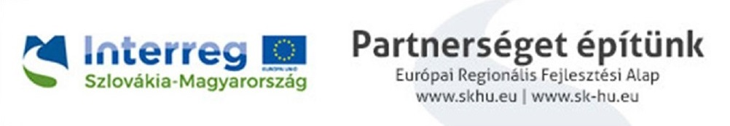
PRESS RELEASE

Innovation service providers for a strengthened competitiveness of local enterprises

The South-East of Slovakia and the North-East of Hungary are among the poorest European regions with low economic output and high unemployment rates. Local enterprises often have low productivity and competitiveness due, among other things, to obsolete technologies, poor innovation skills and the lack of R+D infrastructure at these companies.

In order to develop these areas, the commercial and industrial chambers of the border regions have launched their ’Cross-border Innovation Service Portfolio’ project. The project, budgeted at EUR 162 174.60, will be implemented within the Interreg V-A Slovakia-Hungary Cooperation Program, co-financed by the European Regional Development Fund (ERDF).
As a result of the cooperation, a catalogue of innovation service providers has been drafted to provide information on R+D infrastructure and innovation services for enterprises in the South-East of Slovakia and the North-East of Hungary, thus encouraging innovation-oriented, cross-border cooperation between enterprises and knowledge providers. This catalogue is available online at https://inno-service.eu/hu/

Service providers and enterprises focusing on development can talk about cooperation at the following business sectoral meetings:
- Meeting of timber industry and forestry professionals – Zvolen, 18 September 2018.
- Mechanical and IT-systems for the mechanical industry – professionals meeting – Eger, 4 October 2018.
- IT professionals’ meeting – Košice, 25 October 2018.
- Meeting of metallurgical industry professionals – Salgótarján, 13 November 2018.
- Meeting of automotive industry professionals – Miskolc, 4 December 2018.

The project’s leading partner (chief beneficiary):
The Banská Bystrica Branch of the Chamber of Commerce and Industry of Slovakia
Project partners:
The Košice Branch of the Chamber of Commerce and Industry of Slovakia
Borsod-Abaúj-Zemplén County Chamber of Commerce and Industry
Heves County Chamber of Commerce and Industry
Nógrád County Chamber of Commerce and Industry

Further information:
Andrea NYERGES, Nógrád County Chamber of Commerce and Industry
Phone: +32/520-868 Mobile phone: +36-30-598-1259
Email: mkikmszt@nkik.hu

The content of this press release does not necessarily reflect the position of the European Union.

